**Tugas mysql query**

1. select nama_obat from obat order by nama_obat desc limit 4;

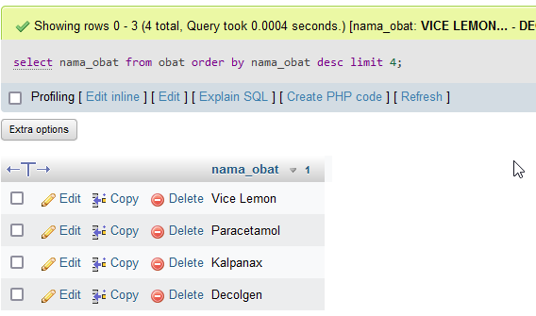

1. select nama_pasien from pasien order by nama_pasien asc limit 3,5;

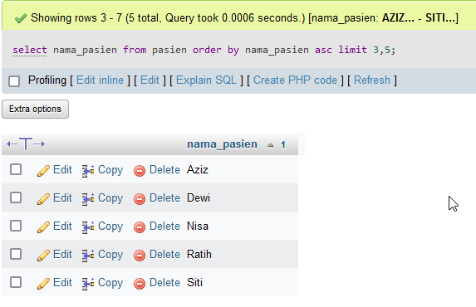

1. select id_pasien, nama_pasien from pasien where jenis_kelamin='P';

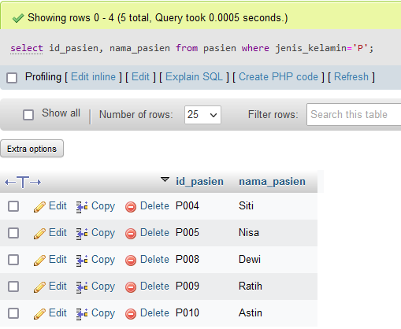

1. select nama_pasien,jenis_kelamin from pasien where nama_pasien like '%su%';

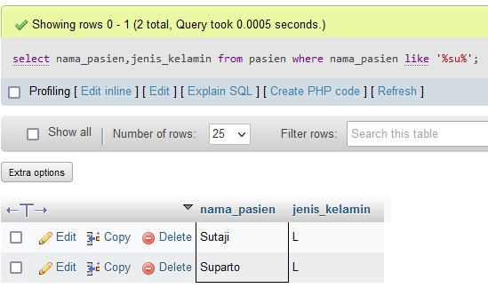

1. select id_pasien, keluhan from sakit where keluhan like '%flu%' order by id_pasien desc;

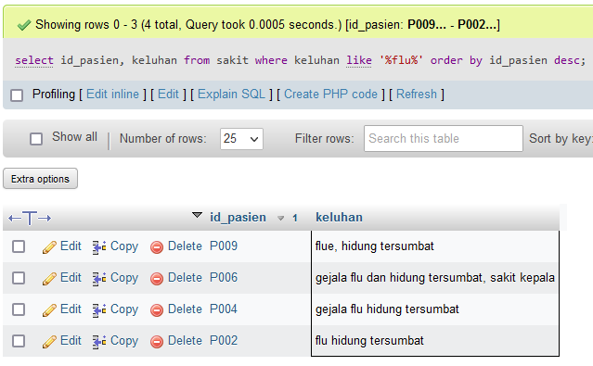

1. select jenis_kelamin, count(jenis_kelamin) as 'jumlah' from pasien group by jenis_kelamin;

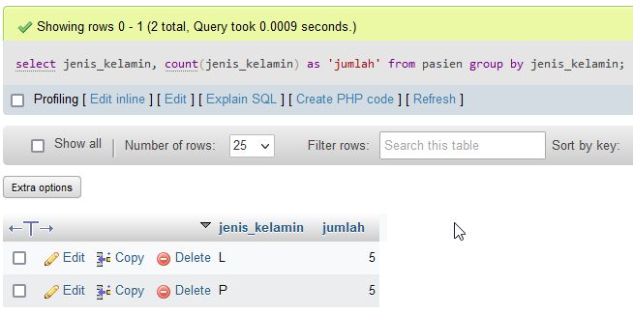

1. select id_pasien, tanggal_beli from pembelian where tanggal_beli between '2023-05-24' and '2023-05-26';

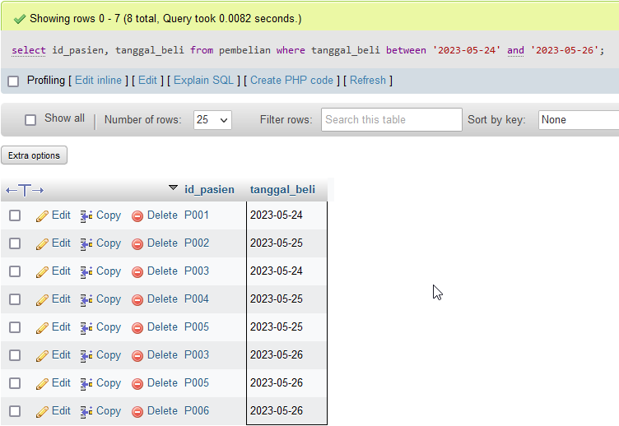

1. select nama_obat, stok from obat where stok >='30';

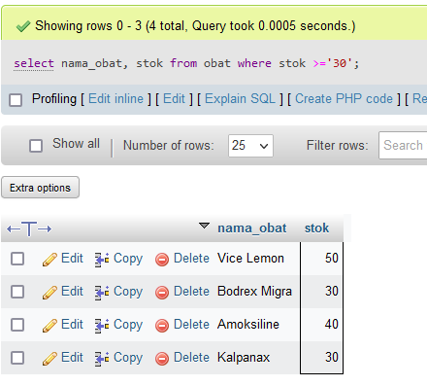

1. select count(nama_obat) as 'jumlah_obat', sum(stok) as 'jumlah_seluruh', sum(harga) as 'total' from obat;

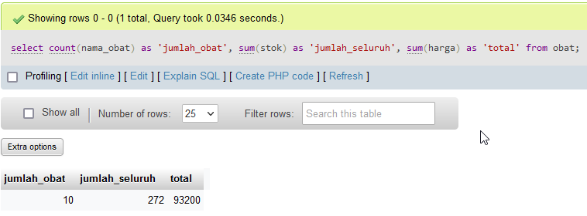

1. select nama_pasien, max(umur) as 'umur max' from pasien where jenis_kelamin='P';

